**Icon Development**

**What is a trademark?**  
1. A trademark can be a word, phrase, symbol, or design that distinguishes the source of the goods or services. Also, as trade dress, it can be the appearance of a product or its packaging, including size, shape, color, texture, graphics, and appearance (e.g, retail store or website).

* When you want to share your app playground with others, you can create an icon for it using an image from your Photos or Files (or another app), or you can select a placeholder image from a preset collection of icon
* To [submit your app to the App Store](https://support.apple.com/guide/playgrounds-ipad/share-a-playground-itc65b2d9a15/4.2/ipados/16.0#itc331695559), you need to create a custom icon for it using an image imported from your Photos, Files, or another app. You can’t use a preset icon when submitting an app to App Store Connect.
* Choose an icon for your app.
  + If you’re submitting your app to App Store Connect, select Custom and use an image imported from Photos, Files, or another app—not a placeholder icon.
  + If you’re not submitting your app to App Store Connect, you can choose a placeholder icon from a collection of preset icons and select an accent color for it.
* Seems to be no trademark necessary for icon photo. If you distribute your app through the App Store, you must provide a specific version of your app icon to represent your app on the App Store. In the Project navigator, select the asset catalog and add the App Store icon to the App Store well in the app icon set. The location of the icon is different depending on the platform.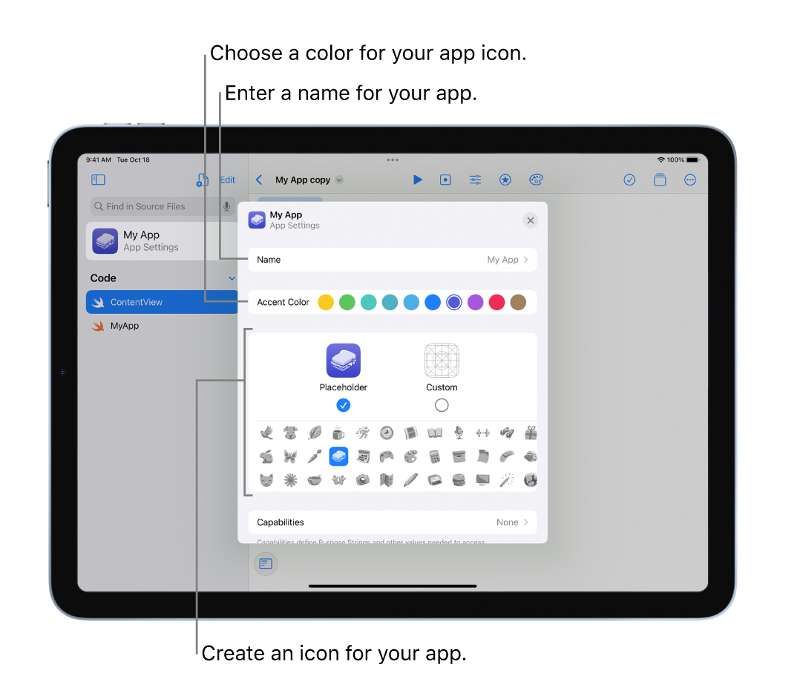

**Creating an App Icon**

When you create your project from a template, it automatically includes a default asset catalog (Assets.xcassets) that contains the AppIcon set.

If you don’t have a default asset catalog or existing AppIcon set or you want to provide an alternate, you can add an app icon set to an asset catalog manually.

1. In the Project navigator, select an asset catalog.
2. Click the Add button (+) at the bottom of the outline view.
3. In the pop-up menu, choose a platform, and select [OS] App Icon. Xcode creates a new app icon set with the name AppIcon.

**App Icon Variations**

Variations of your app icon appear throughout the system in places like the Home screen, Settings, and search results. Specify these variations in the AppIcon set.

1. In the Project navigator, select the asset catalog with the AppIcon set.
2. In the Finder, drag variations of the app icon to the wells in the detail area that match their resolutions and use cases.

**Sample Code**

To load a system icon you use the new **UIImage(systemName:)** initializer. In its most basic form it looks like this:

**let** paperPlane = UIImage(systemName: "paperplane.fill")

**let** action = UIImage(systemName: "square.and.arrow.down")

You can request specific weights of your icon by creating an instance of **UIImage.SymbolConfiguration** like this:

**let** boldConfig = UIImage.SymbolConfiguration(weight: .bold)

**let** boldBell = UIImage(systemName: "bell", withConfiguration: boldConfig)

**let** largeConfig = UIImage.SymbolConfiguration(textStyle: .largeTitle)

**let** largeBolt = UIImage(systemName: "bolt", withConfiguration: largeConfig)